Advert: 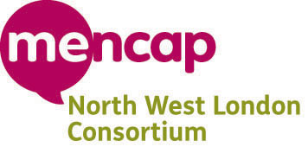

Job Title: Part time Team Leader 20 hours
Salary: £13,750 per annum
Are you a skilled team leader? Can you communicate on different levels and see a project through from beginning to end? Do you want to make a difference and enable people who use care services to have a voice and be heard? A consortium of six North West London local Mencaps have been awarded a three year Innovation Grant from the Department of Health. One skilled Team Leader is required to work alongside the Projector Director, and an existing Team Leader to implement and run the Expect the Best project, ensuring its rollout and future sustainability. As a team leader you will be responsible for supporting a team of quality checkers with learning disabilities and other disabilities who will assess the quality of services across three of six boroughs in London.
Expect the Best has been set up as a pilot to implement the vision of the white paper ‘Caring for our Future: Reforming Care and Support’ which highlights the need for improved quality among health and social care provision. Expect the Best will co-ordinate quality checking of care services in collaboration with local authorities, report back on findings to providers, commissioners and Healthwatch and provide training and advice to providers to help them to improve services. The long term aim is to encourage sign-up of the project among local authorities both inside and outside the pilot area and to roll out Expect the Best nationally. The post will be based in Harrow but the successful applicant will be required to travel to other boroughs to oversee Quality Checks of services and provide onsite training.

For an application pack please contact volunteer@harrowmencap.org.uk 0208 8698484
Closing date 8th November 2013

