Day Trip to Woburn Safari Park
Visit to Woburn Safari was a great day out, seeing the animals was very exciting and interesting.
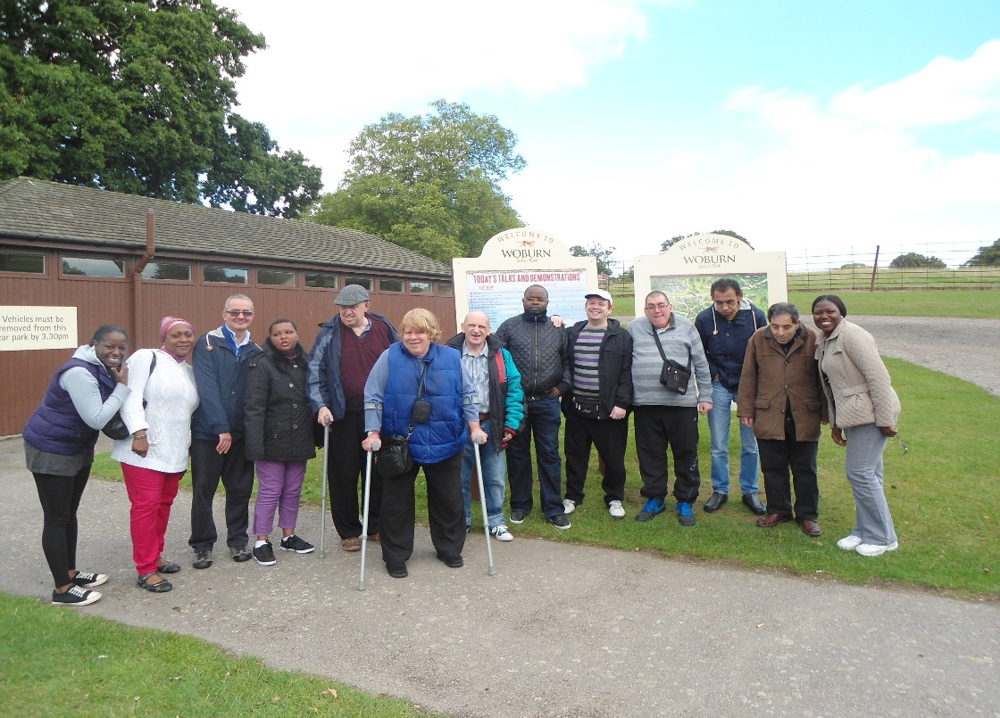

Peter ‘I like the lions which I find very interesting, the way they had to separate the female’s lions from the male lion for his safety. Also I like the train ride around the park, but I would have like to see more monkeys in the park. I was very pleased to see the tigers and rhino’s.
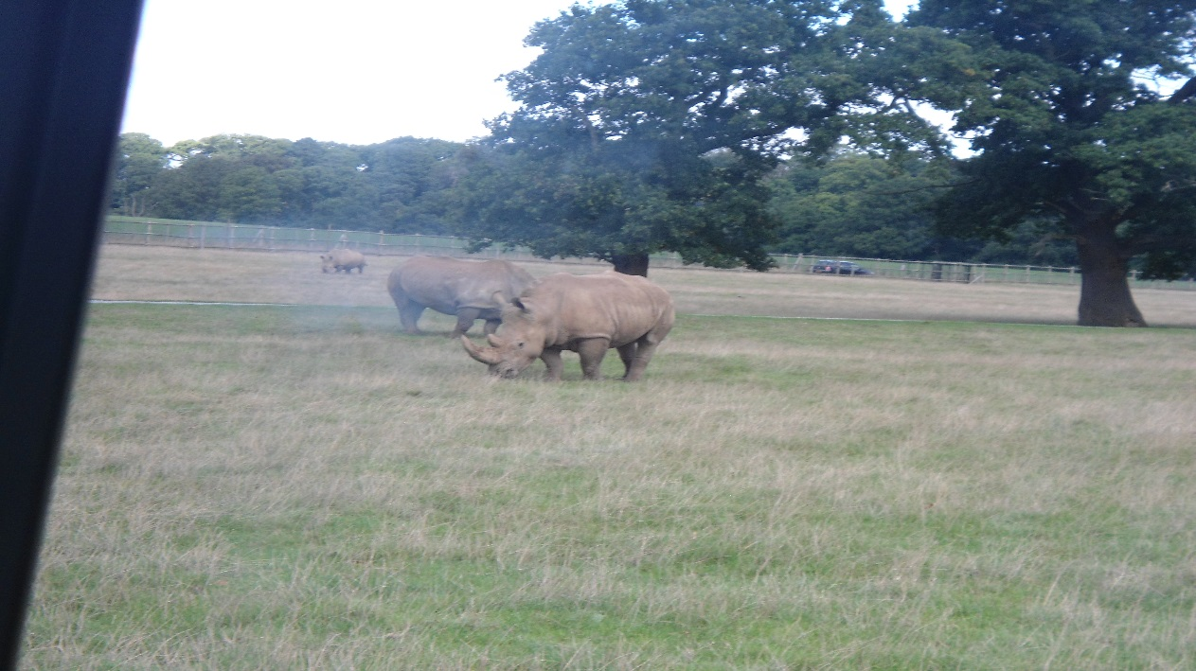
Nooran ‘I like the safari Park, the animals was very nice to see. My favourite was the sea lions. The cup of tea was also very nice and would like to visit the park again’.
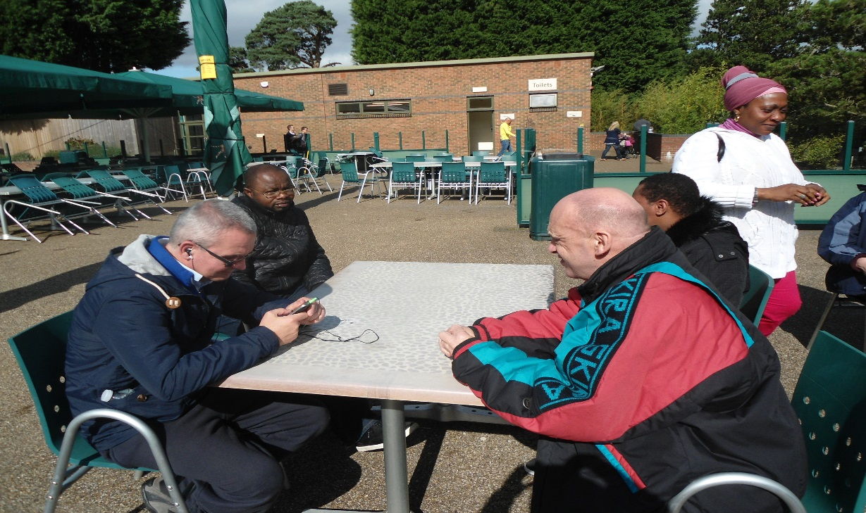

John E ‘It was very good, I like the elephants and monkeys. I would like to go on another trip with Equal People’.
Mark ‘I took so many pictures of different animals, the animals was so close to me. It was great’.
Tobie ‘It was very good and I enjoyed the park but I did not get to see all the animal due to fact I cannot walk very well. It was good for the mini bus to take us round the park to see most of the animals.
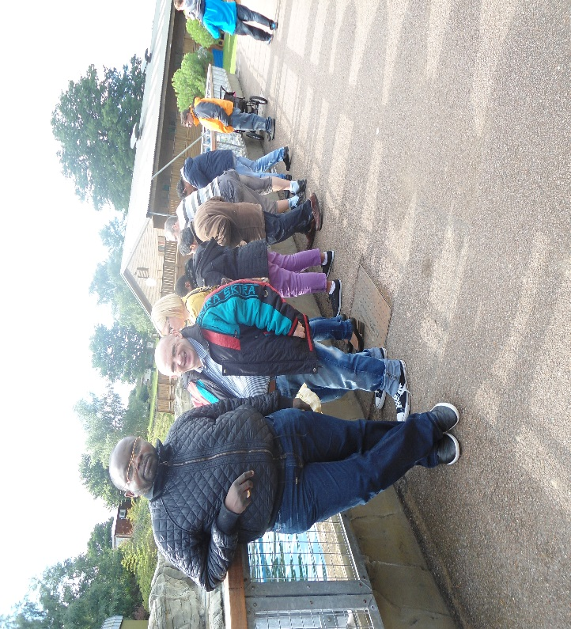
Dean ‘It was a great day to go to a safari Park. It didn’t take us long to get there which was good. I was very excited and then happy to get to park. The animals were great to see and so interesting. I like the wolf and the lions. Also the lunch at the park was very nice too.
Steven ‘It was nice to go out to see the animals. The monkeys and the other animals. I saw the penguins being fed which was exciting.

